Case Studies & Guesstimates for Entertainment Industries

Cover Page
Name: Ankit Mishra
Domain: Entertainment Industry
Chosen Company: Netflix
Date:

The entertainment industry has transformed significantly in the digital era, becoming one of the most influential sectors in the global economy. Today, streaming platforms allow users to access movies, TV shows, documentaries, music, and live entertainment anytime and anywhere through internet-based services. This convenience and accessibility have changed how audiences consume content, reducing dependency on traditional television and movie theatres. Entertainment platforms also break geographical barriers by offering global content to users across different countries and cultures. Continuous technological advancements such as artificial intelligence, cloud computing, and recommendation systems further enhance user experience and engagement.
Data scientists play a major role in the growth and success of the entertainment industry. By analysing user watch history, viewing patterns, search behaviour, and engagement metrics, they help platforms understand customer preferences and improve content recommendations. Their expertise allows companies to personalise user experiences, predict trending genres, optimise streaming quality, and improve customer retention. Data scientists also support business decisions through audience analytics, churn prediction, and content performance analysis. By leveraging data-driven insights, entertainment platforms can enhance customer satisfaction, improve operational efficiency, and maintain a strong competitive advantage in the rapidly growing digital entertainment market.
Product Dissection
1. Platform Selection
Question: Choose a leading platform from a domain related to the entertainment industry. Justify your selection by discussing the platform's popularity, impact, and relevance in its industry.
Answer: Netflix
Popularity: Netflix is one of the world’s most popular entertainment streaming platforms. It provides movies, TV shows, documentaries, anime, and original content to millions of users across more than 190 countries. Netflix became highly popular because it allows users to watch content anytime and anywhere through smartphones, smart TVs, laptops, and tablets. Its user-friendly interface, personalized recommendations, and high-quality original content such as Stranger Things, Squid Game, Wednesday, and Money Heist have helped it build a massive global audience.
Impact: Netflix has completely transformed the entertainment industry by changing how people consume content. Earlier, audiences mainly depended on cable television or movie theatres, but Netflix introduced on-demand streaming, which gave users the flexibility to watch content according to their own schedule. It also popularized binge-watching culture and encouraged the growth of OTT (Over-The-Top) streaming services globally. Through artificial intelligence, recommendation systems, and data analytics, Netflix improved customer experience and set new standards for digital entertainment platforms.
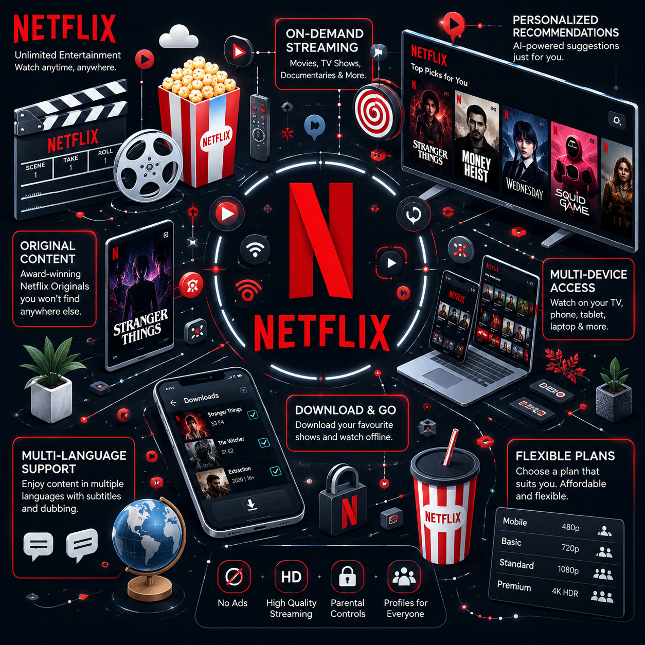Relevance: Netflix remains highly relevant in today’s digital era because consumers prefer personalized, affordable, and convenient entertainment services. The platform continuously uses advanced technologies such as AI, machine learning, and cloud computing to improve recommendations, optimize streaming quality, and increase customer engagement. Its multi-language support, global accessibility, and original content production make Netflix one of the leading and most influential platforms in the entertainment industry.
2. Core Features and Functionalities
Question: Research and list the core features and functionalities of the selected platform. Describe how these features contribute to the platform’s success and user engagement.
Answer: Core Features and Functionalities of Netflix
- Personalized Recommendations: Netflix uses artificial intelligence and machine learning algorithms to recommend movies and TV shows based on users’ watch history, ratings, preferences, and viewing behavior. This helps users easily discover content they are likely to enjoy.
- Vast Content Library: Netflix offers a huge collection of movies, TV shows, documentaries, anime, and original content across multiple genres and languages. This wide variety attracts different types of audiences and keeps users engaged for longer periods.
- Netflix Originals: Netflix produces exclusive original content such as Stranger Things, Squid Game, Wednesday, and Money Heist. These exclusive shows create a strong competitive advantage and encourage users to maintain subscriptions.
- Multi-Device Accessibility: Netflix can be accessed on smartphones, smart TVs, laptops, tablets, and gaming consoles. This flexibility allows users to watch content anytime and anywhere.
- Offline Downloads: Users can download movies and TV shows to watch later without an internet connection. This feature improves convenience for users who travel or have limited internet access.
- Continue Watching Feature: Netflix remembers where users stopped watching and allows them to continue from the same point across devices. This creates a smooth and uninterrupted viewing experience.
- Multi-Language Support: Netflix provides subtitles and dubbing in multiple languages, making international content accessible to global audiences and increasing user reach.
- Smart Search and Content Discovery: Users can search content using titles, genres, actors, or languages. Netflix also categorizes content into trending, recommended, and popular sections for easier discovery.
- Flexible Subscription Plans: Netflix offers different subscription plans based on user needs and budgets. This increases accessibility and attracts customers from different income groups.
- Ad-Free Streaming Experience: Netflix provides uninterrupted entertainment without advertisements, improving user satisfaction and overall viewing experience.
- AI-Based Streaming Optimization: Netflix automatically adjusts video quality according to internet speed, reducing buffering and ensuring smooth streaming.

Contribution to Success and User Engagement
- Convenience: Features such as multi-device access, offline downloads, and continue watching provide flexibility and convenience, making Netflix highly user-friendly.
- Personalized Experience: AI-driven recommendations help users quickly discover relevant content, increasing watch time and customer engagement.
- Customer Retention: Exclusive Netflix Originals, personalized suggestions, and ad-free streaming encourage users to continue subscriptions for longer periods.
- Global Reach: Multi-language support and diverse international content allow Netflix to attract audiences from different countries and cultures.
- Improved User Experience: The platform’s simple interface, smooth streaming quality, and smart content discovery improve overall customer satisfaction.
- Competitive Advantage: Netflix Originals and advanced recommendation systems differentiate Netflix from competitors in the OTT streaming industry.
- Data-Driven Engagement: Netflix continuously analyzes user behavior and viewing patterns to improve recommendations, optimize content strategy, and increase customer loyalty.
These features collectively make Netflix one of the most successful and highly engaging entertainment streaming platforms in the world.
3. Real World Problems
Question: Identify the real-world problems that the platform aims to solve. Discuss how the platform addresses these problems through its features and functionalities.
Answer: Real-World Problems Addressed by Netflix

- Limited Access to Entertainment:
- Problem: Earlier, people mainly depended on cable television or movie theatres for entertainment, which limited accessibility and flexibility.
- Solution: Netflix provides online streaming services that allow users to watch movies and TV shows anytime and anywhere using internet-connected devices.
- Fixed TV Schedules:
- Problem: Traditional television required viewers to watch shows at fixed timings, which was inconvenient for many users.
- Solution: Netflix offers on-demand streaming, allowing users to watch content whenever they want according to their own schedule.
- Difficulty in Discovering Relevant Content:
- Problem: Users often spend a lot of time searching for movies or shows that match their interests.
- Solution: Netflix uses artificial intelligence and machine learning to provide personalized recommendations based on viewing history, ratings, genres, and user preferences.
- Language and Regional Barriers:
- Problem: Many users are unable to enjoy international content because of language differences.
- Solution: Netflix provides subtitles, dubbing, and multi-language support, making content accessible to global audiences.
- Expensive Entertainment Options:
- Problem: Frequent movie theatre visits and cable TV subscriptions can be costly for users.
- Solution: Netflix offers affordable subscription plans with unlimited streaming access, making entertainment more cost-effective.
- Device Dependency:
- Problem: Traditional entertainment systems were mostly limited to television sets.
- Solution: Netflix supports multiple devices such as smartphones, tablets, laptops, smart TVs, and gaming consoles, allowing users to stream content from anywhere.
- Internet Connectivity Issues:
- Problem: Users with unstable internet connections may face difficulty watching online content continuously.
- Solution: Netflix provides offline download features that allow users to download content and watch later without internet access.

- Lack of Personalized Entertainment Experience:
- Problem: Traditional entertainment platforms offered the same content suggestions to every user.
- Solution: Netflix personalizes recommendations, homepages, and notifications according to each user’s behavior and interests.

How Netflix Addresses These Problems
- On-Demand Streaming: Provides flexibility by allowing users to watch content anytime without fixed schedules.
- Personalized Recommendations: Uses AI and data analytics to recommend relevant content and improve user satisfaction.
- Multi-Language Support: Expands accessibility by offering subtitles and dubbing in multiple languages.
- Affordable Subscription Plans: Makes entertainment accessible to users from different income groups.
- Multi-Device Accessibility: Allows seamless viewing across smartphones, laptops, tablets, and TVs.
- Offline Downloads: Improves convenience for users with limited internet access.
- Netflix Originals: Provides exclusive, high-quality content that increases engagement and customer loyalty.
These features and functionalities collectively solve major entertainment-related challenges, helping Netflix become one of the most successful and customer-focused streaming platforms globally.

Database Management & Schema Design
4. Schema Design
Question: Based on the features and functionalities you have identified, design a schema that reflects the platform’s data structure. Define the key entities, attributes, and relationships that underpin these features.
Answer: Schema Design for Netflix
The schema design for Netflix should reflect its core features and functionalities, ensuring efficient data management and enabling the platform to deliver a seamless and personalized streaming experience. Below is an overview of the key entities, attributes, and relationships:
Key Entities and Attributes :

- User
Attribute | Type | Description
UserID | Primary Key | Unique identifier for the user
Name | String | Name of the user
Email | String | User email address
Password | String | Account password
Phone | String | Mobile number
Country | String | User country
SubscriptionPlan | String | Current subscription plan
RegistrationDate | Date | Date of account creation

- Subscription
Attribute | Type | Description
SubscriptionID | Primary Key | Unique identifier for subscription
UserID | Foreign Key | References User(UserID)
PlanType | String | Basic / Standard / Premium
Amount | Decimal | Subscription amount
PaymentStatus | String | Paid / Pending
RenewalDate | Date | Subscription renewal date

- Movies
Attribute | Type | Description
MovieID | Primary Key | Unique identifier for movie/show
Title | String | Name of movie or TV show
Genre | String | Content genre
Language | String | Content language
ReleaseYear | Integer | Year of release
Duration | String | Duration of movie/show
Rating | Decimal | Average user rating
Description | String | Summary of content

- WatchHistory
Attribute | Type | Description
HistoryID | Primary Key | Unique watch history ID
UserID | Foreign Key | References User(UserID)
MovieID | Foreign Key | References Movies(MovieID)
WatchDate | Date | Date of watching
WatchDuration | Integer | Total watch time
CompletionPercentage | Decimal | Percentage watched

- Review
Attribute | Type | Description
ReviewID | Primary Key | Unique review ID
UserID | Foreign Key | References User(UserID)
MovieID | Foreign Key | References Movies(MovieID)
Rating | Decimal | User rating
Comment | String | User feedback
ReviewDate | Date | Date of review

- Watchlist
Attribute | Type | Description
WatchlistID | Primary Key | Unique watchlist ID
UserID | Foreign Key | References User(UserID)
CreatedDate | Date | Date watchlist created

- Watch list Item
Attribute | Type | Description
WatchlistItemID | Primary Key | Unique watchlist item ID
WatchlistID | Foreign Key | References Watchlist(WatchlistID)
MovieID | Foreign Key | References Movies(MovieID)
AddedDate | Date | Date content added

- UserPreferences

Attribute | Type | Description
PreferenceID | Primary Key | Unique preference ID
UserID | Foreign Key | References User(UserID)
FavoriteGenre | String | Preferred genre
PreferredLanguage | String | Preferred language
PreferredActor | String | Favorite actor

- Recommendation

Attribute | Type | Description
RecommendationID | Primary Key | Unique recommendation ID
UserID | Foreign Key | References User(UserID)
MovieID | Foreign Key | Recommended content
RecommendationScore | Decimal | AI recommendation score
RecommendationDate | Date | Date of recommendation

- Device

Attribute | Type | Description
DeviceID | Primary Key | Unique device ID
UserID | Foreign Key | References User(UserID)
DeviceType | String | Mobile / TV / Laptop
LoginTime | Timestamp | User login time
Location | String | Device login location

Relationships

From Table | From Attribute | To Table | To Attribute | Relationship Type
User | UserID | Subscription | UserID | One-to-Many
User | UserID | WatchHistory | UserID | One-to-Many
Movies | MovieID | WatchHistory | MovieID | One-to-Many
User | UserID | Review | UserID | One-to-Many
Movies | MovieID | Review | MovieID | One-to-Many
User | UserID | Watchlist | UserID | One-to-Many
Watchlist | WatchlistID | WatchlistItem | WatchlistID | One-to-Many
Movies | MovieID | WatchlistItem | MovieID | Many-to-One
User | UserID | UserPreferences | UserID | One-to-Many
User | UserID | Recommendation | UserID | One-to-Many
Movies | MovieID | Recommendation | MovieID | Many-to-One
User | UserID | Device | UserID | One-to-Many

Explanation of Schema Design:

Feature Area | Explanation
User Management | The User and Subscription tables manage user profiles and subscription plans.
Content Management | The Movies table stores information related to movies and TV shows.
Personalized Recommendations | The Recommendation and UserPreferences tables support AI-based personalized suggestions.
User Engagement | WatchHistory and Review tables track viewing behavior and feedback.
Convenience Features | Watchlist allows users to save content for future viewing.
Multi-Device Streaming | Device table manages streaming activity across multiple devices.

Benefits of This Schema Design:

Benefit | Description
Efficient Data Management | Organizes streaming and user data efficiently
Better Scalability | Supports millions of global users
Personalized Experience | Enables AI-driven recommendations
Improved User Engagement | Tracks user activity and preferences
Faster Analytics | Helps analyze viewing behavior quickly
Better Subscription Management | Manages payment and subscription details effectively

This schema design captures the essential data interactions and relationships within Netflix, supporting its core functionalities efficiently. It ensures scalability, performance, and a highly personalized entertainment experience, contributing to Netflix’s overall success and customer satisfaction.
5. ER Diagram Creation
Question: Utilise tools like the Miro platform or similar applications to create an illustrative Entity-Relationship (ER) diagram. This diagram should vividly depict the entities, attributes, and relationships present within your schema design.
Answer: The ER (Entity-Relationship) Diagram for Netflix visually represents the structure of the Netflix database system. It shows how different entities such as Users, Movies, Subscription, WatchHistory, Reviews, Watchlist, Recommendations, and Devices are connected with each other through primary keys and foreign keys.

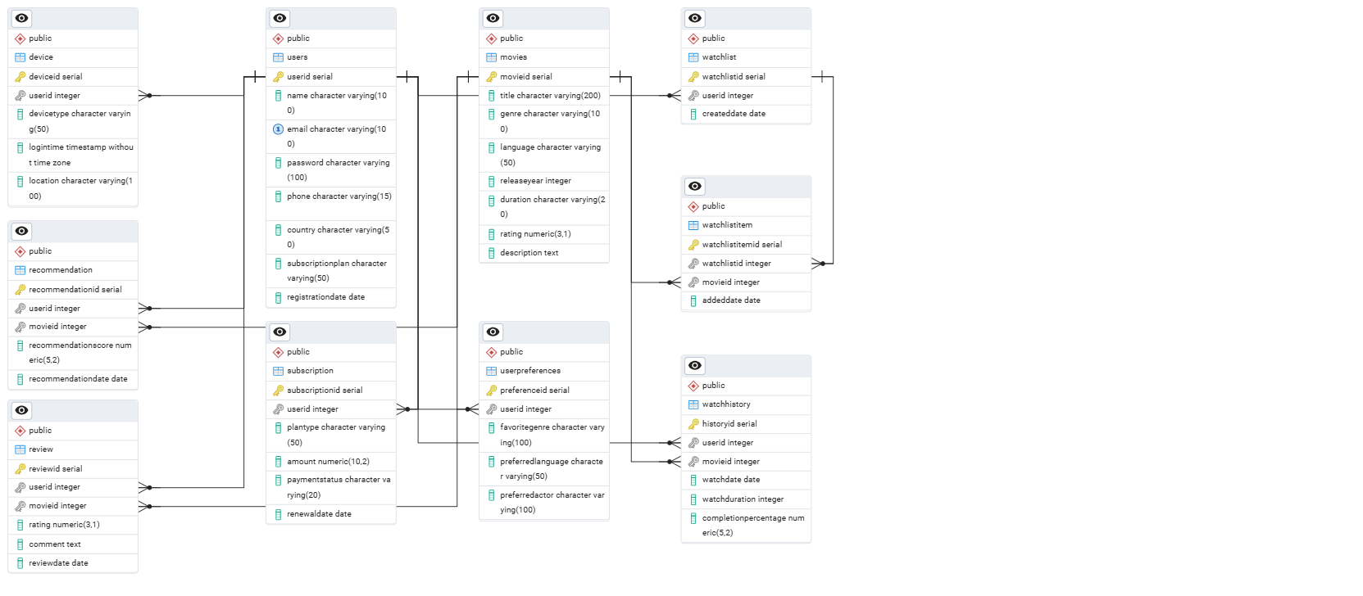

Revenue and Profit Growth Strategies
Netflix is one of the world’s leading OTT streaming platforms, offering movies, web series, documentaries, and original content globally. Despite strong market dominance, increasing competition from platforms like Amazon Prime Video, Disney+, and Hotstar has increased pressure on profitability.
The objective of this case study is to propose data-driven strategies that can increase Netflix’s overall profit by at least 25% through:
- Revenue growth
- Customer retention
- Cost optimization
- Personalized user engagement
- Market expansion
- Analysing Netflix’s Current Status
Category | Analysis
Revenue Sources | Subscription plans, advertisements, partnerships, licensing
Major Expenses | Content production, cloud infrastructure, marketing, licensing
Customer Behaviour | Binge watching, mobile streaming, personalized recommendations
Key Challenges | Password sharing, churn rate, high production costs
Growth Opportunities | Ad-supported plans, regional content, AI recommendations

- Current Revenue Structure
Revenue Stream | Contribution
Premium Subscription Plans | 55%
Standard Plans | 25%
Mobile Plans | 10%
Advertisement Revenue | 5%
Partnerships & Licensing | 5%

- Current Expense Structure
Expense Category | Contribution
Original Content Production | 40%
Licensing Costs | 20%
Cloud & Infrastructure | 15%
Marketing & Promotions | 15%
Employee & Operations | 10%

- Key Problems Affecting Profitability
Problem | Impact
High Content Production Cost | Reduced profit margins
Subscriber Churn | Loss of recurring revenue
Password Sharing | Revenue leakage
Low Ad Revenue | Untapped monetization
Intense Competition | Reduced customer acquisition

- Strategies to Increase Profit by 25%
- Introduce AI-Based Personalized Recommendations (+5%)
Objective: Increase watch time and user retention.
Strategy: Use Machine Learning recommendation systems
Analyze:
      - Watch history
      - Genre preferences
      - Search behavior
      - Device usage
Expected Benefits
Metric | Expected Improvement
User Engagement | +20%
Retention Rate | +10%
Churn Reduction | -8%
Technologies Used
- Python
- TensorFlow
- PostgreSQL
- Recommendation Algorithms

- Expand Ad-Supported Subscription Plans (+4%)
Objective: Increase revenue from price-sensitive customers.
Strategy
- Launch low-cost plans with advertisements
- Target students and emerging markets
Expected Benefits
Metric | Improvement
New Subscribers | +15%
Ad Revenue | +40%
Market Penetration | +12%

- Reduce Password Sharing (+3%)
Objective: Convert shared users into paid subscribers.
Strategy
- Multi-device authentication
- OTP-based login verification
- Household-based subscription tracking
Expected Benefits
Metric | Improvement
Paid Subscribers | +8%
Revenue Leakage Reduction | +12%

- Regional Content Expansion (+5%)
Objective: Increase subscriptions in local markets.
Strategy
- Indian regional web series
- Korean dramas
- Anime
- Local documentaries
Expected Benefits
Metric | Improvement
Regional Subscribers | +20%
User Retention | +15%

- Optimize Content Production Costs (+3%)
Objective: Reduce unnecessary expenses.
Strategy
- Analyze content performance using analytics
- Stop low-performing projects
- Invest more in high ROI genres
Expected Benefits
Metric | Improvement
Production Cost Reduction | -10%
Profit Margin | +5%

- Improve Customer Retention (+3%)
Objective: Reduce churn rate.
Strategy
- Loyalty rewards
- Personalized notifications
- Continue Watching optimization
- Smart recommendations

Expected Benefits
Metric | Improvement
Churn Reduction | -12%
Customer Lifetime Value | +18%

- Partnership & Bundling Strategy (+2%)
Objective: Increase subscriber base.
Strategy: Partner with:
- Telecom companies
- Internet providers
- Smart TV brands
Expected Benefits
Metric | Improvement
New Users | +10%
Brand Reach | +15%

6. Total Expected Profit Increase
Strategy | Profit Impact
AI Recommendations | 5%
Ad-Supported Plans | 4%
Password Sharing Control | 3%
Regional Content | 5%
Cost Optimization | 3%
Customer Retention | 3%
Partnerships | 2%

Total Expected Profit = 25%
7. Implementation Timeline
Phase | Activities
Phase 1 | Data collection & analytics
Phase 2 | AI recommendation deployment
Phase 3 | Ad-supported plan launch
Phase 4 | Regional content expansion
Phase 5 | Password sharing controls
Phase 6 | Optimization & monitoring

- Resources Required
Resource | Purpose
Data Scientists | Recommendation systems
ML Engineers | AI model deployment
Cloud Infrastructure | Streaming scalability
Marketing Team | Campaign management
Content Analysts | Performance analysis

- KPIs to Measure Success
KPI | Target
Subscriber Growth | +20%
Revenue Growth | +30%
Churn Rate | Below 5%
Average Watch Time | +25%
Ad Revenue | +40%

Using data analytics, machine learning, and targeted business strategies, Netflix can strengthen its market position while improving user satisfaction and long-term profitability.
Guesstimate
Flowchart for Guesstimation
Step |  | Details | Calculation
1 | India Population (2025 Estimate) |  | 1.4 Billion
2 | Internet Penetration = 55% |  | 1.4B × 0.55 = 770 Million
3 | OTT Platform Users = 60% of internet users |  | 770M × 0.60 = 462 Million
4 | Netflix Market Share = 12% of OTT users |  | 462M × 0.12 = 55 Million
5 | Paid Netflix Subscribers = 65% |  | 55M × 0.65 = 36 Million
6 | Average Monthly Subscription Fee |  | ₹500
7 | Annual Revenue Per User |  | ₹500 × 12 = ₹6000
8 | Total Netflix Annual Revenue |  | 36M × ₹6000

Final Estimation: Total Estimated Netflix Revenue in India (2025) = ₹216 Billion
Visual Breakdown:
India Population
↓
Internet Users
↓
OTT Users
↓
Netflix Users
↓
Paid Subscribers
↓
Monthly Subscription
↓
Annual Revenue

Assumptions Used:
Parameter | Assumption
Internet Penetration | 55%
OTT Adoption | 60%
Netflix Market Share | 12%
Paid Conversion Rate | 65%
Average Monthly Fee | ₹500

Factors That Can Increase Revenue Further
Strategy | Impact
Ad-supported Plans | More users from tier-2 and tier-3 cities
Regional Content | Higher engagement
Password Sharing Controls | More paid accounts
Telecom Bundles | Faster subscriber growth
AI Recommendations | Better retention

Cohort Analysis & A/B Testing for Netflix
What is Cohort Analysis?
Cohort analysis is a data analytics technique used to study the behavior of a group of users over a specific period of time. A cohort is a group of users who share a common characteristic, such as the month they subscribed to Netflix. This method helps Netflix understand user retention, engagement patterns, subscription renewals, and churn behavior over time.
Importance of Cohort Analysis for Netflix
Benefit | Explanation
Retention Tracking | Helps Netflix understand how long users stay subscribed
Churn Analysis | Identifies when users cancel subscriptions
Behavioral Insights | Tracks user watch patterns and engagement
Personalized Recommendations | Improves AI-based content suggestions
Revenue Optimization | Helps improve long-term customer lifetime value

Netflix Cohort Analysis Example
Step 1: Data Collection
User ID | Signup Date | Subscription Plan | Watch Hours | Renewal Date
101 | 2025-01-10 | Premium | 45 hrs | 2025-02-10
102 | 2025-01-15 | Premium | 60 hrs | 2025-03-15
103 | 2025-02-05 | Standard | 30 hrs | 2025-03-05

Step 2: Define Cohorts
Cohort | Users | Cohort Period
Jan 2025 | 101,102 | January 2025
Feb 2025 | 103 | February 2025
Mar 2025 | 104,105 | March 2025

Step 3: Track Metrics
Metric | Jan Cohort | Feb Cohort | Mar Cohort
Number of Users | 2 | 1 | 2
Avg Watch Hours | 52 hrs | 30 hrs | 48 hrs
Subscription Renewals | 2 | 1 | 2
Retention Rate | 100% | 100% | 100%

Monthly Retention Formula
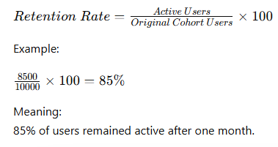
Netflix Retention Heatmap Example
Cohort | Month 1 | Month 2 | Month 3 | Month 4
Jan 2025 | 100% | 85% | 72% | 60%
Feb 2025 | 100% | 82% | 70% | 58%
Mar 2025 | 100% | 88% | 76% | 65%

Actionable Insights for Netflix
Insight | Action
High churn after Month 3 | Launch new exclusive content
Premium users retain longer | Promote premium plans
Users watching Originals stay active | Invest more in Netflix Originals
Mobile users churn faster | Improve mobile streaming experience

Strategies to Reduce Churn
Strategy | Benefit
Personalized Recommendations | Improves engagement
Regional Content | Increases local audience retention
Loyalty Discounts | Encourages subscription renewal
Push Notifications | Re-engages inactive users
Better Streaming Quality | Improves user satisfaction

What is A/B Testing?
A/B Testing is a method of comparing two versions of a feature or experience to determine which one performs better. Netflix uses A/B testing to optimize user engagement, retention, and subscription conversions.
Netflix A/B Testing Example
Scenario
Netflix wants to test two onboarding experiences for new users.
Version A |  | Version B
Basic onboarding | Interactive personalized onboarding

Hypothesis:
Personalized onboarding will improve watch time and premium subscription conversions.

A/B Testing Process
1. Create Variants
Version A (Control)
- Simple signup
- Minimal recommendations
Version B (Variant)
- Genre selection
- Personalized recommendations
- Watchlist setup
2. Random Assignment
Group | Users
Version A | 50%
Version B | 50%

3. Track Key Metrics
Metric | Purpose
Retention Rate | Measures returning users
Conversion Rate | Measures paid subscriptions
Watch Time | Measures engagement
Churn Rate | Measures user drop-off

Conversion Rate Formula


Example Results
Metric | Version A | Version B
7-Day Retention | 72% | 69%
Conversion Rate | 11% | 17%
Avg Watch Time | 4.5 hrs | 7 hrs

Final Analysis
Advantages of Version B
- Higher subscription conversions
- Better engagement
- Increased revenue
Disadvantage
- Slightly lower retention

Business Recommendation
Netflix should:
- Implement Version B
- Improve onboarding flow further
- Continue iterative A/B testing
DBMS & Data Architecture
1. ACID Properties in Netflix Subscription System
Question: How do ACID properties ensure reliability in Netflix’s subscription and streaming transaction system?
Answer:
- Atomicity: Ensures that subscription payment, plan activation, and account update happen completely or not at all. If payment fails, no subscription is activated.
- Consistency: Maintains valid data — if a user upgrades to Premium, billing and streaming access update correctly.
- Isolation: Prevents issues when multiple users access or update the same account simultaneously.
- Durability: Once payment or watch history is saved, the data remains secure even after a server crash.

2. Indexing for Fast Content Search
Question: Netflix users search movies by actor, genre, or language. How does indexing improve performance?
Answer:
Netflix can create indexes on frequently searched columns such as:
- movie_title
- actor_name
- genre
- language
This allows faster search results without scanning the full database. Full-text indexing also improves recommendation and search efficiency. However, too many indexes can slow updates, so balance is important.

3. Normalization in Netflix Database
Question: How would you normalize Netflix content and user data?
Answer:
- 1NF: Store atomic values (one movie title per row).
- 2NF: Separate movies, genres, actors, and subscriptions into different tables.
- 3NF: Remove redundant information such as storing actor details separately.
This reduces redundancy, improves consistency, and simplifies database maintenance.
4. Denormalization for Analytics
Question: Would Netflix use normalization or denormalization for analytics?
Answer:
For reporting and recommendation systems, Netflix may use denormalized tables combining:
- users
- watch history
- ratings
- subscription plans
This improves query performance and speeds up analytics dashboards.
5. Partitioning Large Streaming Logs
Question: Netflix stores billions of streaming logs. How can partitioning help?
Answer:
Netflix can partition data by:
- date
- country
- region
Example:
- January logs stored separately from February logs.
This improves query speed, analytics performance, and backup management.
6. Sharding for Global Scalability
Question: How can sharding help Netflix manage global traffic?
Answer:
Netflix can distribute users across multiple database servers:
- Asia users → Shard A
- Europe users → Shard B
- America users → Shard C
This improves scalability, reduces latency, and handles millions of concurrent users efficiently.
7. Handling High Concurrency
Question: How does Netflix avoid conflicts when millions stream simultaneously?
Answer:
Netflix uses:
- transaction isolation levels
- optimistic concurrency control
- distributed caching systems
This prevents lost updates and ensures smooth streaming experiences.
8. Query Optimization
Question: A Netflix analytics query is slow. How would you optimize it?
Answer:
- Add indexes on frequently queried columns
- Use EXPLAIN PLAN
- Create materialized views
- Use partition pruning
- Optimize joins
These methods reduce execution time significantly.
9. Data Warehouse vs Data Lake
Question: How would Netflix use Data Lakes and Data Warehouses?
Answer:
- Data Warehouse: Stores structured data like subscriptions, payments, and reports.
- Data Lake: Stores raw streaming logs, clickstream data, subtitles, and recommendation data.
Netflix later transforms raw data into analytical formats for business insights.

10. OLTP vs OLAP in Netflix
Question: What databases does Netflix use for transactions and analytics?
Answer:
- OLTP: Handles real-time subscription payments and streaming activity.
- OLAP: Used for analytics, reporting, recommendation systems, and content performance analysis.
OLTP focuses on speed; OLAP focuses on complex analysis.
11. Backup & Recovery Plan
Question: How would Netflix recover after a database crash?
Answer:
Netflix uses:
- incremental backups
- transaction logs
- real-time replication
- point-in-time recovery
This minimizes data loss and ensures business continuity.
12. Ensuring Data Security
Question: How does Netflix protect user data?
Answer:
Netflix secures data using:
- encryption at rest and in transit
- role-based access control (RBAC)
- authentication systems
- regular audit logging
Sensitive user and payment data are masked or encrypted.
13. Slowly Changing Dimensions (SCD)
Question:
How would Netflix track changes in user subscription plans over time?
Answer:
Netflix can use:
- SCD Type 2
to maintain historical subscription records with version tracking and effective dates.
This helps analyze customer upgrade and downgrade behavior historically.
14. SQL vs NoSQL
Question: Which databases would Netflix use?
Answer:
- SQL Databases: Structured data like subscriptions, billing, and user accounts.
- NoSQL Databases: Watch history, recommendations, sessions, and caching.
Netflix often uses a hybrid database architecture.
15. Handling Schema Changes
Question: How can Netflix safely add new features to the database?
Answer:
Netflix uses:
- version-controlled migrations
- backward compatibility
- staged deployment strategies
This ensures smooth updates without breaking existing services.
16. Data Ingestion from Multiple Sources
Question: How does Netflix ingest streaming and user data?
Answer:
Netflix uses:
- Apache Kafka
- AWS Kinesis
- Airflow pipelines
to collect streaming logs, device data, clickstream events, and user interactions into centralized systems.
17. ETL Pipeline Design
Question: How would Netflix design an ETL pipeline?
Answer:
- Extract: Collect data from streaming apps and databases.
- Transform: Clean, aggregate, and process viewing behavior.
- Load: Store processed data into analytics warehouses.
Netflix may use Spark, AWS Glue, or Databricks for scalable ETL operations.
18. Handling Schema Changes in ETL
Question: How does Netflix manage evolving schemas?
Answer:
Netflix uses:
- schema versioning
- CDC (Change Data Capture)
- flexible formats like Avro and Parquet
This allows pipelines to adapt without failures.
19. Real-Time Streaming Data Pipeline
Question: How does Netflix process real-time streaming data?
Answer:
Netflix uses:
- Kafka streams
- Spark Streaming
- Redis caching
- distributed processing systems
This enables real-time recommendations and monitoring with very low latency.
20. ETL Failure & Recovery
Question: How would Netflix ensure consistency after ETL failure?
Answer:
Netflix uses:
- retry mechanisms
- checkpointing
- transactional processing
- monitoring tools like Prometheus
This ensures pipelines can recover safely without duplicate or corrupted data.

